My Story: U.S. Nationals
Mike Long
U.S. Nationals has been the defining event of my Magic career. Having made Top 16 at five out of the first six events, Top 8 four times, and made the coveted cut to Top 4 and the U.S. National Team three out of the first six years, I felt a comfortable dominance over the event. It was, and still is, the event that seems to represent my career the best, from the things that I've been the most proud of to the bitterest of defeats.

In minutes my Magic career would change, maybe forever...
As the 2000 Nationals began to draw to its close, it appeared that once again I would challenge for the title. I had won the Standard portion of the event, posting a 5-1 record with my Accelerated Blue deck, enough to allow me to squeak back into the Top 8. I had also been able to build a pretty good deck in the Master's draft going on simultaneously, giving me the opportunity to sweep both events. In minutes my Magic career would change, maybe forever.
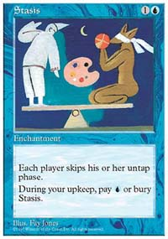
I began at the first U.S. Nationals in 1995 by qualifying for the event with a run through the grueling U.S. Open. Dubbed the "Meatgrinder", the Open has been the proving ground for many of our most famous players including Jon Finkel and newcomer Alex Borteh. My performance there qualified me to play in the main event, where I qualified for the first U.S. National Team and got a neat write-up in George Baxter's book Deep Magic, which featured my Icy Manipulator-Orgg deck. The next year I made a repeat appearance on the National team when Matt Place and I both piloted an exciting new deck called "Turbo Stasis", pioneered by a little-known Scandinavian named Tommi Hovi, to Top 4 finishes. My multiple and heated confrontations with Head Judge Tom Wylie, though, reinforced my reputation as a troublemaker.
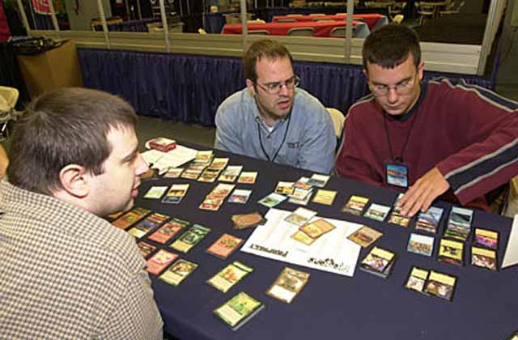
Peter Leiher and Mike Long at Pro Tour-New York
My 1998 run at the U.S. National Championship resulted in several things. First, it produced what was, at the time, the best Swiss record in a major Magic event, as I went 6-0 in Sealed Deck and 5-1 in Standard. Second - it also saw the biggest scandal in the game's history, as I received a match loss in my final match versus Bryce Currence for a card suspiciously found face down on the seat where I was characteristically perched. Third, with the scandal came the most-watched video in Magic's short history, chronicling, among other things, my dramatic charge toward the Championship and my glorious defeat at the hands of newcomer Matt Linde. Finally, it put some money in my pocket, which I used to start a new game store. Peter Leiher, a couple of other friends and I opened "The End" that August in Charlottesville, Virginia.
Up until that point, I had more or less been a full time pro, having won a decent amount of money before even graduating from college. I was finally a bit tired of play, though, and was happy to take my winnings and apply them to something that might last longer than my Magic career. I poured myself into our new business, working hard at everything from sweeping and mopping to running our fledgling Elementary Magic League.
The following year I would skip a Pro Tour for the first time. I missed Pro Tour-Rome because it conflicted with the beginning of one of our Elementary Magic League seasons. The time I spent in the store was rewarding-our community grew steadily-but the time I spent there didn't decrease. I would make an appearance, what I thought would be my last, at Pro Tour-Chicago.
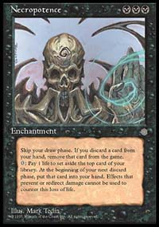
I returned home to work full-time on my shop, but eventually I decided to make my final appearance at the 1998 Magic Invitational in Barcelona. (The decision was made when my mother threatened to appear in my place if I planned to give up a free trip to her favorite country, Spain.) At that tournament I played a series of pet decks from around my store, including a Standard Merfolk deck, which I used to make the Finals, and Leiher's old school Type 1 Necro deck, which I used to win the Championship over Sturla Bingen.
Satisfied with going out a winner, I returned home once again to work on our business. Perhaps I was lying to myself, because a month later I was all too easily convinced to catch a last minute flight bound for California to compete in PT-LA, where I played my way back into the Top 8.
This time, though, my retirement would appear a little more believable, as I skipped both Pro Tour-London and the World Championships in Tokyo while I focused on the growing Pokémon trend and our new combined Magic, Pokémon, and Warhammer Elementary League.
Once again, an easy excuse to leave semi-retirement presented itself when I found that I could play in the first team Pro Tour, PT-DC, with long-time friend Brian Schneider and the help of Justin Gary, only an hour from my home. Our surprisingly synergistic team finished just out of the final four as eventual champions "Your Move Games" defeated us in the last round.
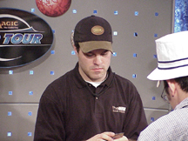
Long plays against Benafel in the semifinals
I was baited out of retirement once again by PT-LA, which had been so good to me in years past. Once again at the last second, I used my frequent flier miles to hop over to LAX, where, a short Super Shuttle ride away, I would better my last year's performance by one, making Top 4 before losing to newcomer Chris Benafel. My retirement became less believable even to myself as I also opted to compete in PT-NY, although I did fail to put in an appearance in Chicago.
I found myself with a compelling reason to compete when Wizards announced an exclusive draft that would feature only the game's top players. As one of the top ranked players by the DCI, I was fortunate enough to be invited. One catch-it was to be held at U.S. Nationals in Orlando. There was no way I was going to pass, so I decided to forego my retirement and play once again.
Two years after my fateful Finals appearance at U.S. Nationals, I was ready to take another shot at the National Championship. At the end of Day 2, I found myself pitted against Trevor Blackwell in the semifinals of the Master's draft and qualified for the Top 8 of Nationals.
As I prepared to take on Blackwell, our decks were checked. Though I was anxious to get on with the match, my anxiousness was nowhere near that of Blackwell, who kept repeating that he thought he might have misregistered his deck. I told him I was unconcerned with my own and that I was always very careful, and I even went so far as to decline a split with him should one of us get booted from the event.
I should have taken the split. In a rush of activity after a long wait, Jeff Donias informed me that my deck had been carefully reviewed and had been judged to be cleverly stacked. I was tossed from the event and my prize money was taken away, though I would be allowed to compete the next day in the National Championships. I hadn't cheated then, just as I had not two years before, but my reputation for fast play and abrasive behavior had caught up with me, and I could not angrily argue my way out of this sentence.
After a sleepless night I succumbed in the first round of Day 3 to Frank Hernandez's green Stompy deck, and the round after that I was upended in five games by Aaron Forsythe's Angry Hermit deck, eliminating me from Nationals as well.
In two years I had gone from one peak in my career to another, seemingly higher one, only to finish with a crash back to Earth. Though the only action the DCI would take against me in the aftermath of the scandal was a meaningless one-month suspension that ended days before Worlds began, it would become an ominous sign of things to come. In my younger years, this would have been fuel for the fire, but as I became older I didn't see it as persecution. It was more like bad karma, which made it that much harder for me to dust myself off and start again.

